**Imaging Subcellular Structures with Small Molecule Fluorescent Probes**

**Sriram Kanvah Gundimeda**

Department of Chemistry, Indian Institute of Technology Gandhinagar, Palaj, Gandhinagar

E-mail: sriram@iitgn.ac.in

**Abstract**

Donor-acceptor (D-π–A) conjugated organic molecules exhibit versatile chemical, optical, electrical, and biological properties, making them a promising platform for the development of innovative functional materials. These conjugated systems, characterized by low-energy emission and charge-transfer behavior, hold significant potential for diagnostic and analytical applications. Our research focuses on the synthesis and photoresponsive properties of such fluorophores for advanced biological imaging. By modulating auxochromes, we have developed a series of fluorophores capable of selectively staining sub-cellular organelles, including the plasma membrane, lipid droplets, endoplasmic reticulum, lysosomes, and mitochondria. These fluorescent probes also enable real-time monitoring of physiological processes, such as viscosity changes and inter-organelle interactions, thereby expanding their applicability in medical diagnostics. Furthermore, this presentation will highlight our design strategies and findings in sub-cellular imaging, as well as recent advancements in receptor-mediated targeting and imaging of estrogen receptor-positive (ER+) breast cancer cells, paving the way for targeted therapeutic interventions

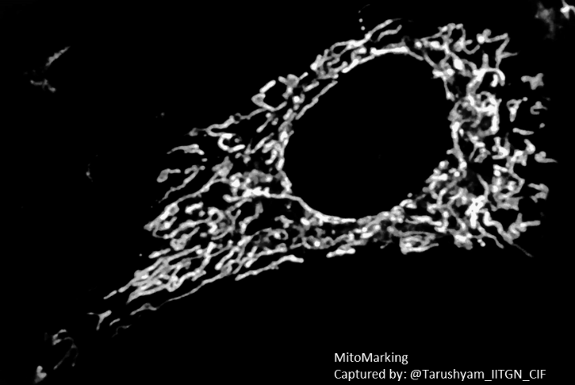

**References and**

1. Rajput, Deeksha et al. *Org Biomol Chem*, 2023, 21, 8554.
2. Mansuri, Shabnam et al. *J. Mat. Chem. B*, 2024, 12. 2028.
3. Rajput, Deeksha et al; *J. Mat. Chem. B*, 2024, 12, 4698.
4. Dubey, Yogesh et al. *J. Mat. Chem.B*, 2024, 12. 4962-4974.
5. Ghorpade, Mohini et al. *ChemBioChem*, 2024, e202400273.