**Senate agenda: 25.62.06.**

**Decision: The Senate discussed MS Thesis Guidelines (IISER Mohali) and approved the following guidelines.**

******************************************************

**Part I**

**MS Thesis Guidelines (IISER Mohali)**

**General Guidelines**

The following are the guidelines for carrying out MS thesis research by BSMS students of IISER Mohali.

**Terminology:**

**Internal Supervisor/co-supervisor:** In the present document, the term “Internal Supervisor/Co-supervisor” refers to a faculty member of IISER Mohali who is performing the role of a supervisor/co-supervisor for an MS project. Note that the prefix “internal” will be restricted only to this document (for the ease of description). At all other relevant places, only the term “Supervisor/Co-supervisor” will be used.

**External Supervisor/Co-supervisor:** In the present document, the term “External Supervisor/Co-supervisor” refers to a faculty member/researcher from an institution other than IISER Mohali who is performing the role of a supervisor/co-supervisor for an MS project. Note that the prefix “external” will be restricted only to this document (for the ease of description). At all other relevant places, only the term “Supervisor/Co-supervisor” will be used.

**Administrative Guide:** In the present document, the term “Administrative guide” refers to a faculty member of IISER Mohali who is performing the role of an administrative guide for an MS project research to be done by the student in a host institution.

**Host Institution:** Any institution other than IISER Mohali, within India or abroad, where an MS project is being carried out.

1. **Thesis Structure:**

The MS thesis project is to be carried out under two-course headings, PRJ501 and PRJ502 . Of these, PRJ501 must be completed before registering for PRJ502 .

1. **Eligibility criteria:**

A bonafide BSMS student is eligible to undertake the MS thesis project and as it is desired that the MS thesis work be started after most of the course requirements have been completed, only students who have completed 163 credits with at most two F grades are permitted to start work on MS thesis. Relaxation of up to 8 credits may be given on account of overloads in two semesters on submitting a request for approving the overload.

1. **Duration of the project:**
   1. PRJ501 and PRJ502 are each expected to run for the duration of one semester. Therefore, the total duration of the MS thesis is two semesters.
   2. PRJ501 will run during the monsoon semester (August to December) while PRJ502 will run during the spring semester (January to April).
      1. Exception: For students who are delayed by more than a semester in their academic program, i.e., students who can register for their PRJ501 in their 10th semester or later, the following exceptions may be made. Such students with more than a semester of delay can register for PRJ501 in the Spring semester (their 10th semester or later semesters) or during the Summer semester (after completing their 10th semester). After completing their PRJ501 , such students can register for PRJ502 during the summer semester or during the monsoon semester.
2. **Research Location:**

**4.1 Case 1: Research at IISER Mohali**

4.1.1 Conducted under any faculty member of IISER Mohali.

4.1.2 Research is expected to be carried out, typically, at the IISER Mohali campus.

4.1.3 In this case, the IISER Mohali faculty member will be designated as the MS thesis Supervisor.

4.1.4 For each student undertaking MS thesis research, a three-member committee consisting of the MS thesis supervisor and two other IISER Mohali faculty members will be constituted and designated as the MS thesis committee. The MS thesis committee will monitor the progress and evaluate the performance of the student and award the grades for PRJ501 and PRJ502 .

4.1.5 The internal Supervisor will sign the MS thesis and the MS thesis committee will sign the evaluation forms and certificate of examination (in the thesis).

**4.2 Case 2: Research at an external host institution where an IISER Mohali faculty member has a collaboration.**

4.2.1 Conducted under a faculty member/researcher at any other institution (Host Institution) provided a faculty member of IISER Mohali has collaboration with the faculty member of the Host Institution.

4.2.2 Research is expected to be carried out at the host institution and/or at the IISER Mohali campus. The student must be physically present in the Host Institution/IISER Mohali campus.

4.2.3 In this case, the IISER Mohali faculty member and the faculty member from the host institution will be designated as MS thesis Co-Supervisors.

4.2.4 For each student undertaking MS thesis research, a three-member committee consisting of the internal co-supervisor and two other IISER Mohali faculty members will be constituted and designated as the MS thesis committee which will monitor the progress of the student.

4.2.5 The grade for part A of PRJ501 /PRJ502 will be awarded by that co-supervisor with whom the relevant research was carried out (for example, if PRJ501 was carried out at the host institution, the grade for part A of PRJ501 will be awarded by the external co-supervisor and so on).

The MS thesis committee will award the grade for Part B of PRJ501 and PRJ502 .

4.2.6. The two co-supervisors are required to sign the MS thesis. The MS thesis committee will sign the evaluation forms and certificate of examination (in the thesis). The external co-supervisor would be invited to be part of the thesis evaluation committee.

4.2.7. The internship will be governed by the terms and conditions set out in an agreement to be signed by the student, external co-supervisor/authorized signatory of Host Institution and IISER Mohali.

**4.3 Case 3: Research at an external host institution**

4.3.1 Conducted under a faculty member/researcher at any institution (Host Institution) other than IISER Mohali, provided that:

4.3.1.1 A faculty member of IISER Mohali with overlapping research interests OR subject expertise agrees to act as the Administrative Guide.

OR

4.3.1.2 A faculty member of IISER Mohali agrees to act as the Administrative Guide and the MS thesis committee has members with overlapping research interests OR subject expertise.

4.3.2 In this case, the faculty member from the host Institution will be designated as MS thesis supervisor (for both PRJ501 and PRJ502). The willing IISER Mohali faculty member will be designated as the Administrative Guide.

4.3.3 Research is expected to be carried out at the Host Institution. The student must be physically present in the Host Institution for the duration of the project. In case the research visit of the student to the Host Institution is planned only for one semester, then, a clear plan of action for the other semester about how the research will be carried on at the IISER Mohali campus must be presented in the prescribed format. This plan must be endorsed by both the supervisor and the Administrative Guide.

4.3.4 For each student undertaking MS thesis research, a three-member committee consisting of the Administrative Guide and two other IISER Mohali faculty members will be constituted and designated as the MS thesis committee which will monitor the progress of the student. The external MS thesis supervisor would be invited to be part of the thesis evaluation committee.

4.3.5 The MS thesis supervisor from the host institution will award a letter grade for Part A of PRJ501 and PRJ502 .

The MS thesis committee will award the grade for Part B of PRJ501 and PRJ502 .

4.3.6 The MS thesis supervisor is required to sign the MS thesis. The MS thesis committee will sign the evaluation forms and certificate of examination (in the thesis).

4.3.7. The internship will be governed by the terms and conditions set out in an agreement to be signed by the student, external supervisor/authorized signatory of Host Institution and IISER Mohali.

The Senate indicated that all relevant operational guidelines will be circulated to the students

**********************************************************************

**Important Instructions.**

1. The operational guidelines (part II) are given below.
2. Students and Colleagues are requested to pay attention to the operational guidelines.
3. These guidelines would be effective from MS21 Batch onwards with immediate effect.
4. MS21 student **who already obtained NOC** need to submit the remaining documents immediately.
5. Applicable agreement (Form 3) has to be made in consultation with the external supervisor and Dean Outreach Office.
6. The (a) IISER Mohali supervisor, or (b) administrative guide and (c) student have to ensure to inform the external supervisor about the grading and evaluation criteria and guidelines applicable.

All MS21 students eligible for MS thesis, **MUST** submit **Form 1: MS thesis intent form** by 31st March 2025. All the students must adhere to the deadline strictly.

---------------------------------------

**Part II**

**Operational Guidelines**

**Terminology:**

**Internal Supervisor/co-supervisor:** In the present document, the term “Internal Supervisor/Co-supervisor” refers to a faculty member of IISER Mohali who is performing the role of a supervisor/co-supervisor for an MS project. Note that the prefix “internal” will be restricted only to this document (for the ease of description). At all other relevant places, only the term “Supervisor/Co-supervisor” will be used.

**External Supervisor/Co-supervisor:** In the present document, the term “External Supervisor/Co-supervisor” refers to a faculty member/researcher from an Institution other than IISER Mohali who is performing the role of a supervisor/co-supervisor for an MS project. Note that the prefix “external” will be restricted only to this document (for the ease of description). At all other relevant places, only the term “Supervisor/Co-supervisor” will be used.

**Administrative Guide:** In the present document, the term “Administrative guide” refers to a faculty member of IISER Mohali who is performing the role of an administrative guide for an MS project research to be done by the student in a host institution.

**Host Institution:** Any institution other than IISER Mohali, within India or abroad, where an MS project is being carried out.

1. Registration and Approval process:
   1. It is the student's responsibility to identify supervisor/co-supervisors/administrative guide for their MS thesis project.
   2. Students must complete the PRJ501/PRJ502 registration in the ERP before the deadline.
   3. The eligible students must declare
      1. the name(s) of the supervisor/co-supervisor/administrative guide from IISER Mohali, and
      2. MS thesis plan on the proforma provided (Form 1) on or before 31st March in their 8th semester.
2. Additional requirement for students conducting research in a host institution.

2.1 It is mandatory for such students to obtain a **No Objection Certificate** (NOC) from the Dean Academics office. This can be done by submitting the following:

2.1.1. Duly filled Form 2.

2.1.2. Offer letter from the host institution.

2.1.3. MS Thesis Agreement (Form 3)

**Any violation of this mandatory requirement will attract disciplinary action.**

2.2. During the period of the MS thesis project, the student must be physically present at IISER Mohali campus or at the host institution, as per the approved plan in Form 1.

2.3 In case of a delay in starting the research work at the host institution due to unforeseeable situations (for example, delays due to administrative processes or visa), the student must be physically present at IISER Mohali campus and report to the co-supervisor/administrative guide for this period.

2.4 **It is mandatory for the students to send monthly progress reports to their co-supervisor/ administrative guide at IISER Mohali.**

2.5Upon returning to IISER Mohali, a completed Form 4 must be submitted by the student.

2.6 After receiving NOC, the student must complete all the other processes, such as registration for the PRJ501/502 on ERP, fee payment, etc, in a timely manner.

1. In case of delays in the completion of PRJ501/502, requests for an extension of time must be sent to the Dean Academics through internal supervisor/internal co-supervisor/administrative guide.
2. All correspondence with the Dean Academics should be through internal supervisor/internal co-supervisor/administrative guide and they must be copied on all correspondence.
3. It is mandatory to complete NPTEL courses, if any, by the end of the 9th semester.

**Form 1: MS thesis intent form**

**(The form to be submitted on or before 31st March)**

1. Name of the student:
2. Registration number:
3. Research Location: Pick the correct option that applies to you (please see Part I, Section 4 of the MS thesis guidelines)

Select the case as applicable:

3.1 Case 1: Research at IISER Mohali ☐

3.2 Case 2: Research at an external host institution where an IISER Mohali faculty member has a collaboration ☐

3.3 Case 3: Research at an external host institution ☐

1. If you chose case 2 (3.2) or case 3 (3.3), then, which part of the MS thesis will you be conducting outside IISER Mohali?

4.1 Only PRJ501 ☐

4.2 Only PRJ502 ☐

4.3 Both PRJ501 and PRJ502 ☐

5. If you chose either 4.1 or 4.2, attach a one page plan on how you will carry out research at the IISER Mohali campus in the other semester. This plan must be signed by (a). the student (b). the supervisor/ co-supervisor from the host institution and (c). the co-supervisor/administrative guide from IISER Mohali, as the case may be.

6. Start date of the MS thesis project: End date of the MS thesis project:

7. Title of the MS thesis project:

8. Name of the Supervisor/Co-supervisor/Administrative Guide from IISER Mohali along with the Department:

9. Name and address of the host institution:

10. Name and designation of the Supervisor/Co-supervisor from the host institution:

Note: Attach the letter of acceptance from the host institution. For any change in the plan, a new form must be submitted by the deadline of 31st March.

|  |  |
| --- | --- |
| Signature of Student:  Date | Signature: Supervisor/Co-supervisor/Administrative Guide (IISER-Mohali)  Date |

HoD Signature:

|  |  |
| --- | --- |
|  | **Indian Institute of Science Education and Research Mohali**  Knowledge City, Sector – 81, Mohali – 140 306, INDIA |

**FORM 2 : DECLARATION /UNDERTAKING for PROJECT/FIELD WORK**

I, Mr. / Ms.............................................................................Reg.No. .....................................,

Programme............................................................................, Dept. ...................................,

Student of **INDIAN INSTITUTE OF SCIENCE EDUCATION AND RESEARCH MOHALI**, permanent Resident of.........................................................................................................................

Phone No: .......................................... (Give permanent home address with telephone no.),

do hereby undertake the following:

1. I, hereby, declare that, I am going to carry out PROJECT/FIELD WORK (tick one) in ….......

Semester of Academic year …...................................at ....................................................

…........................................................................................................................................

1. I understand that I shall do the course work of 9th semester in 10th semester and vice-versa.
2. I, hereby, declare that, I have informed my parents and supervisor about this.
3. I am aware, as applicable, about the Host University/Institution Safety Policies and Departmental procedures.
4. The risk assessments have been made and the safety provisions relating to the work exist and have been discussed with my Supervisor/Co-supervisor.
5. I have carefully read and fully understood the above mentioned points.

Declared this ___ day of ____________month of ____year.

Signature of the student Signature of Supervisor / Co-supervisor /

Administrative Guide/Mentor

Name_______________ Name_______________

Forwarded by HOD: Sign/date

**Declaration to be included in the MS thesis (Templates)**

(template applicable for case 1 or 3)

**Declaration**

I have carried out the work presented in this dissertation titled “(thesis name)____________________________________________________________ ” under the guidance of Prof./Dr.(Supervisor name) ____________________________ at (institution /university name) __________________________________________.

This work has not been submitted in part or in full for a degree, a diploma, or a fellowship to any other university or institution. Whenever contributions of others are involved, every effort is made to indicate this clearly, with due acknowledgement of collaborative research and discussions.

This thesis is a bonafide record of my original work done by me and all sources listed within have been detailed in the bibliography.

Signature

(of Candidate)

Dated: _________

In my capacity as the supervisor of the candidate's project work, I certify that the

above statements by the candidate are true to the best of my knowledge.

Prof./Dr. _______________

Signature

(of Supervisor)

Dated: _________________

(template applicable for case 2)

**Declaration**

I have carried out the work presented in this dissertation titled “(thesis name)__ ______________ __ ______________ ______________ _____” under the guidance of Prof./Dr.(Co-supervisor name) ____________________________ at IISER Mohali and Prof./Dr.(Co-supervisor name) ______________ at (institution/university name) __________________________________________

This work has not been submitted in part or in full for a degree, a diploma, or a fellowship to any other university or institution. Whenever contributions of others are involved, every effort is made to indicate this clearly, with due acknowledgement of collaborative research and discussions.

This thesis is a bonafide record of my original work done by me and all sources listed within have been detailed in the bibliography.

Signature

(of Candidate)

Dated: _________

In my capacity as the co-supervisor of the candidate's project work, I certify that the

above statements by the candidate are true to the best of my knowledge.

Prof./Dr. _______________

Signature

(of Co-Supervisor)

Dated: _________________

Prof./Dr. _______________

Signature

(of Co-Supervisor)

Dated: _________________

(template applicable for cases 1 and 2)

**Certificate of Examination**

This is to certify that the dissertation titled "_________________________________________________________" submitted by Mr./Ms (Student name)_____________ ______________(Reg. No. MS_______________) for the partial fulfilment of BS-MS Dual Degree programme of IISER Mohali has been examined by the thesis committee duly appointed by the institution. The committee finds the work done by the candidate satisfactory and recommends that the report be accepted.

Prof./Dr. ___________. Prof./Dr. _____________ Prof./Dr. _______________

(Examiner1) (Examiner 2) (Examiner 3)

(Supervisor/Co-Supervisor)

(Signature) (Signature) (Signature)

Dated: ________

(template applicable for case 3)

**Certificate of Examination**

This is to certify that the dissertation titled "_________________________________________________________" submitted by Mr./Ms (Student name)_________________________________________ (Reg. No. MS ________) for the partial fulfilment of BS-MS Dual Degree programme of IISER Mohali has been examined by the thesis committee duly appointed by the institution. The committee finds the work done by the candidate satisfactory and recommends that the report be accepted.

Prof./Dr. ___________. Prof./Dr. _____________ Prof./Dr. _______________

(Examiner1) (Examiner 2) (Examiner 3)

(Administrative Guide)

(Signature) (Signature)

Dated: ________

|  |  |
| --- | --- |
|  | **Indian Institute of Science Education and Research Mohali**  Knowledge City, Sector – 81, Mohali – 140 306, INDIA |

**Form 4: Returning to Campus after PRJ501 and PRJ502-Undertaking**

(To be submitted after returning to IISERM Campus after completing PRJ501/PRJ502)

Student Name:

Roll Number:

Department:

**PRJ501**

The project started on ______________and completed on_____________and returned to IISER Mohali campus on______________

**PRJ502**

The project started on ______________and completed on_____________and returned to IISER Mohali campus on______________

**Comments:**

**Signatures**

Student Supervisor / Co-Supervisor / Administrative Guide

(HoD):

*During the NOC issuance time, students are indicated to inform the Dean Academic on their return. This form will serve as proof of return of the student on the campus. It is a requirement that this form has to be submitted any time after returning on campus but before Thesis submission for Thesis acceptance.

**Senate approved grading policy:**

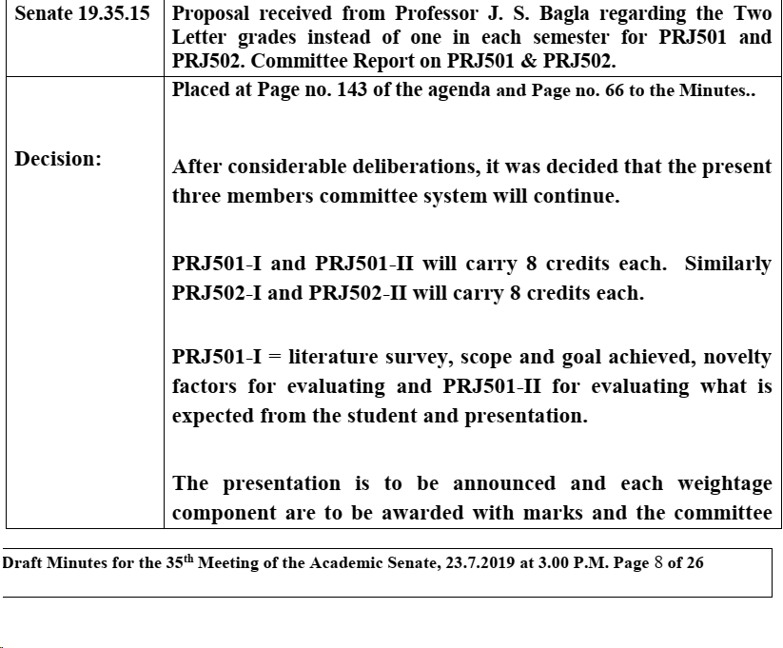

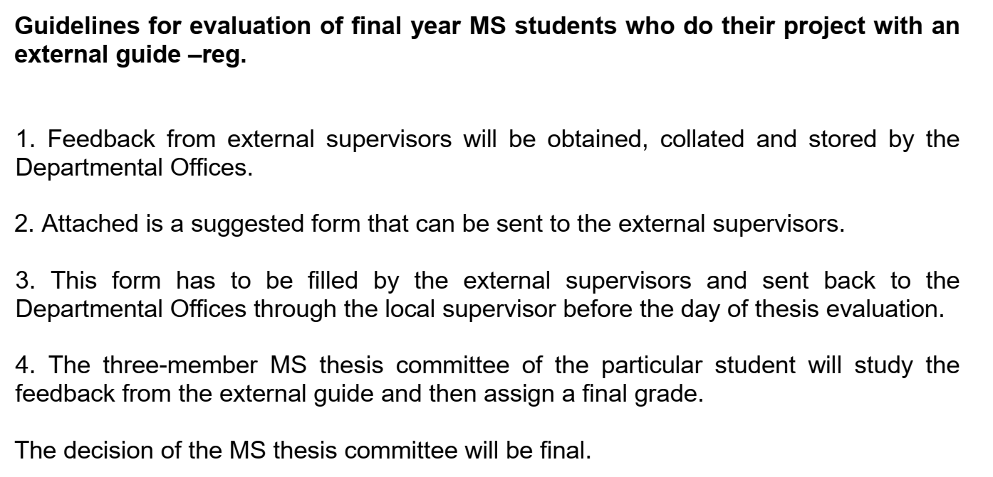

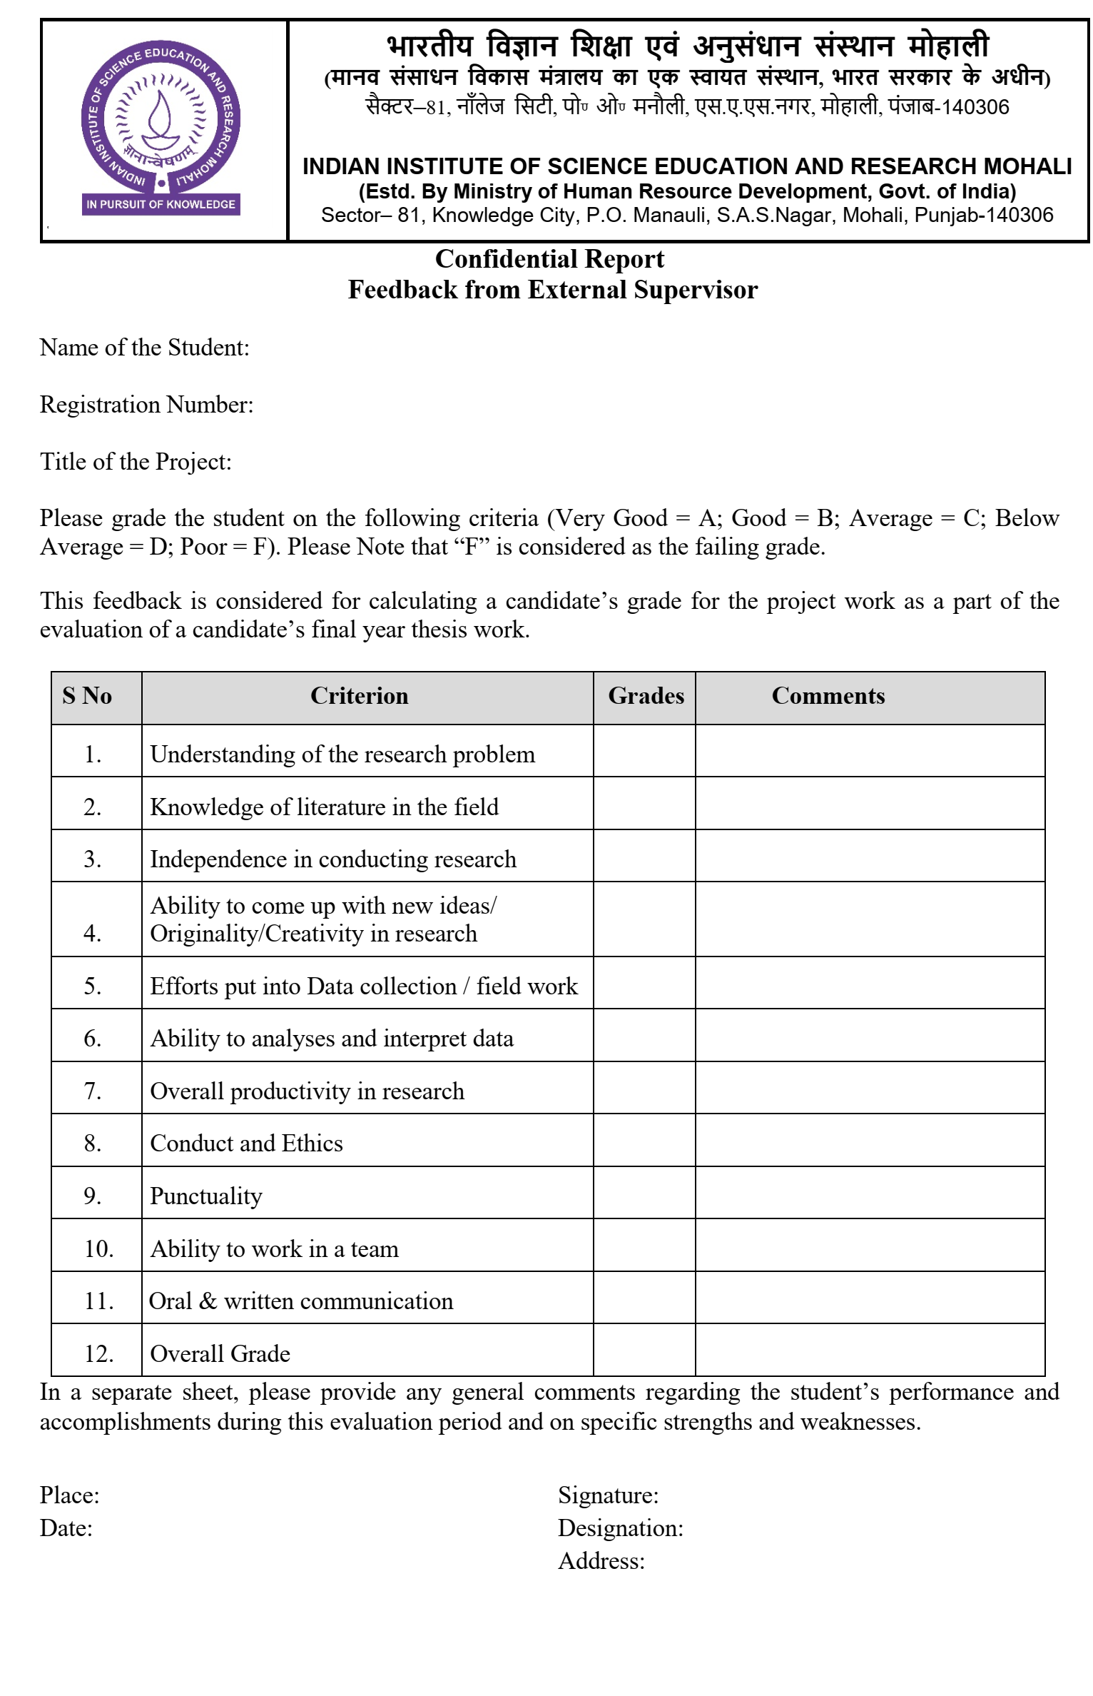

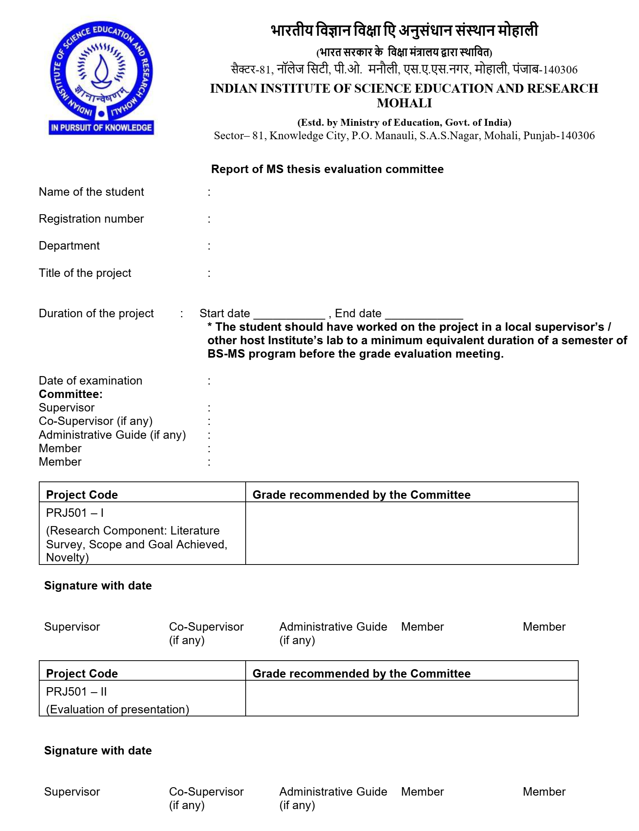

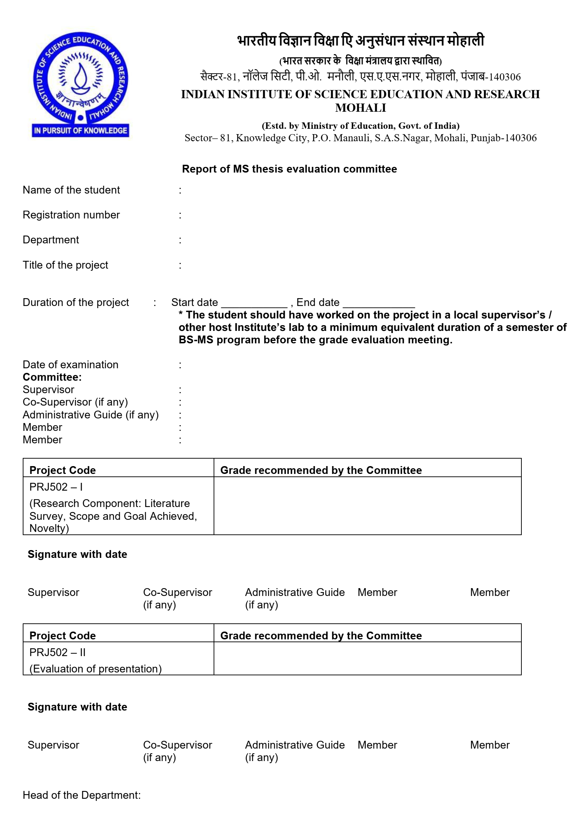

**Form 3: Template of Master’s Thesis Agreement**

This agreement between is executed between IISER Mohali, Host Institution, and the intern. The parties of this Agreement are as under.

1. **IISER Mohali.**

Indian Institute of Science Education and Research Mohali

Knowledge City, Sector 81, Mohali, Punjab, India, PIN 140 306.

Represented by: Professor Amit Kulshrestha

Designation of the representative: Dean, International Relations and Outreach

Phone: +91 172 2240 121 (Extn. 55)

Email: [deanoutreach@iisermohali.ac.in](mailto:deanoutreach@iisermohali.ac.in)

1. **Host Institution.**

[Name]

[Address]

Represented by:

Designation of the representative:

Phone:

Email:

1. **Intern.**

First name Middle name Last name

(*if the host institute is located outside India then the name must be as on the passport*)

Registration number at IISER Mohali:

Sex: F ◻ M ◻ Other ◻

Date of Birth (*in dd/mm/yyyy format*):

Permanent Address:

Phone:

Email:

Department at IISER Mohali:

Name of emergency contact:

Relationship with the emergency contact:

Emergency contact number:

**Definitions**

**Intern** refers to the student currently registered at the BS-MS Dual Degree program of IISER Mohali, who is interested in pursuing a part or the whole of their Master’s Thesis at the Host Institution. The intern is Party III to this Agreement.

**Supervisor** refers to the academic guide affiliated with the Host Institution, who provides academic guidance to the Intern during the period of the Internship, and facilitates conducive conditions and framework toward this.

**Co-supervisor** refers to the joint supervisors, affiliated with IISER Mohali and the Host Institutions, respectively, who provide academic guidance to the Intern during the period of the Internship,and facilitate conducive conditions and framework toward this.

**Administrative Guide** refers to the facilitator, affiliated with IISER Mohali, who executes the procedures concerning the Master’s Thesis of the Intern, and monitors the Intern during their Internship period at the Host Institution.

**Mentor** is an umbrella term thatrefers to Supervisor, Co-supervisor, and Administrative Guide, as the context may be.

**Article 1 – Purpose of the Agreement**

The purpose of this agreement is to define the terms and conditions of the internship to be undertaken by the Intern at the Host Institution. This Agreement governs the Host Institution’s relationship with IISER Mohali and the intern.

**Article 2 – Appointment of Mentors**

2.1 Title of the Master’s Thesis project is:

Duration to be spent by the Intern at the Host Institution is from to

Component of the MS Thesis to be carried out by the Intern at the Host Institution

(*please tick whichever is/are applicable*)

PRJ501 ◻ PRJ502 ◻

2.2 Mentorship of the Intern at IISER Mohali

Role of the mentor at IISER Mohali is:

co-supervisor ◻

administrative guide ◻

Name of the mentor:

Designation:

Department:

Phone:

E-mail

2.3 Mentorship of the Intern at Host Institution

Role of the mentor at Host Institution is:

co-supervisor ◻

supervisor ◻

Name of the mentor:

Designation:

Department:

Phone:

E-mail

**Article 3 - Objective of Internship**

The Internship is for a temporary period of training/research in by the Intern in the Host Institution during which the Intern will conduct their Master’s thesis research. This internship leads to the Master’s Thesis of the Intern with the support of the mentors appointed at IISER Mohali and Host Institution. The intern will be given one or more tasks, in conformance with the Master’s thesis requirements as established by IISER Mohali.

**The Master’s thesis activities planned under this Internship are as under**

(*details of the Master’s thesis project to be specified in 100 words*)

**Article 4 – Terms of Internship**

The weekly duration of the Intern’s presence at the Host Institution will be hours, on a full-time basis.

Number of days of authorized leave during the period of internship at the Host Institution is days per month. The Host Institution shall notify IISER Mohali of any other temporary interruption of the internship (illness, unjustified absence, etc.).

*Please specify if the Intern’s presence at the Host Institution is to be required at night, or on a weekend, or during a public holiday.*

**Article 5 – The Supervision**

5.1 The Intern will be supervised by the co-supervisor from IISER Mohali, as well as the co-supervisor from the host institution as specified in this Agreement.

or

The Intern will be supervised by the supervisor from the Host Institution as designated in this Agreement.

(*Retain the clause that is applicable*)

5.2 During the period for which the Intern is working at the Host Institution,

the co-supervisor appointed by the Host Institution in this Agreement shall be responsible for supervising the Intern and ensuring optimal conditions for the execution of the Internship in accordance with the specified educational requirements.

or

the supervisor appointed by the Host Institution in this Agreement shall be responsible for supervising the intern and ensuring optimal conditions for the execution of the Internship in accordance with the specified educational requirements.

(*Retain the clause that is applicable*)

5.3 Any difficulties encountered in the execution and progress of the internship, whether observed by the Intern or by the co-supervisor/supervisor, must be brought to the attention of the co-supervisor, or the administrative guide from IISER Mohali for a quick resolution of the matter.

5.4 In addition to supervising the research of the Intern, the supervisor/co-supervisor commits to:

5.4.1 Participate in the evaluation of the work of the Intern at the end of the semester(s) and fill out the evaluation form.

5.4.2 Supervise the writing of the Master’s thesis at the end of two semesters of research as per the norms laid down by IISER Mohali and sign the Master’s thesis.

5.5 The supervisor/co-supervisor(s), as well as the Host Institution acknowledge and agree that

5.5.1 A three-member Master’s thesis committee appointed by IISER Mohali shall monitor the progress of the Intern and shall sign the examination form.

5.5.2 The Master’s thesis shall be uploaded to the public domain repository, *Shodhganga*, as per the norms of IISER Mohali within two years of the submission of the thesis.

5.5.3 The supervisor, or a co-supervisor may submit a request for not uploading the thesis in the public domain. The request may be considered on case to case basis by of Senate of IISER Mohali.

### Article 6 – Stipend and Financial Benefits

6.1 The Host Institution shall / shall not provide a stipend of amount per month/period to the Intern.

6.2 If no stipend is provided, the Intern shall be responsible for covering their own expenses.

6.3 **Please specify any additional financial benefit provided by the Host Institutions to the Intern.**

**Article 7 – Health Insurance**

Details of the Health Insurance coverage of the Intern are as under.

7.1 Health Insurance coverage facilitated by IISER Mohali:

Name of the health insurance provider

Name of the plan

Insurance policy number

Dates of validity of this policy

Is this policy valid in the country of the Host Institution?

7.2 Health Insurance coverage from the Host Institution:

(*please provide details*)

7.3 Health insurance coverage valid in the country of host institution purchased by the Intern:

Name of the health insurance provider

Name of the plan

Insurance policy number

Dates of validity of this policy

Amount of the coverage

7.4 Any other health insurance coverage:

(*please provide details*)

### Article 8 – Workplace Accident Coverage

8.1 The Host Institution shall ensure that the Intern is covered by its workplace accident insurance policy.

8.2 If the Host Institution does not have a workplace accident insurance policy, the Intern must obtain independent workplace accident insurance before commencing the internship.

8.3 If the Intern is the victim of an accident during the internship, the Host Institution must immediately notify IISER Mohali of the accident.

Article 9 – Liability and Insurance

9.1 The Host Institution shall ensure that it possesses civil liability insurance to cover any potential damages arising from the Intern’s activities. The Host Institution acknowledges and agrees that it shall have no right to seek compensation or recover such damages from the Sending Institution or the Intern.

9.2 The Sending Institution and Host Institution are not liable for any personal accidents outside of the workplace.

9.3 The Intern agrees to execute an adequate travel assistance insurance contract, including repatriation for health reasons, legal assistance, etc.

**Article 10 – Discipline**

10.1 The Host Institution, IISER Mohali, or the mentors shall not be held responsible for the conduct of the Intern. The Intern shall be subject to the internal disciplinary and regulatory terms of the Host Institution, of which they shall be made aware before the start of the internship, particularly in regard to conduct rules and safety regulations in effect at the Host Institution.

10.2 Host Institution can impose disciplinary sanctions on the Intern only by the decision of IISER Mohali. If such a situation arises, the Host Institution shall inform IISER Mohali of the non-compliance of the Intern and shall provide a supporting evidence for IISER Mohali.

10.3 In case of a particularly serious breach of discipline, the Host Institution shall reserve the right to terminate the Internship and inform IISER Mohali of this decision.

### Article 11 – Intellectual Property Rights

11.1 Ownership of Intellectual Property

11.1.1 If the work done by the intern in a host institution results in patentable inventions, copyrights, or other intellectual property where the Intern has made a substantial and independent contribution, the Intern shall be recognized as an inventor/author, and IISER Mohali shall have the right to claim joint ownership or an appropriate share of the intellectual property, as determined through mutual agreement.

11.1.2 If the work primarily builds upon the pre-existing research of the Host Institution, the Host Institution shall retain primary ownership of the resulting intellectual property, provided that IISER Mohali and the Intern shall be granted a non-exclusive, royalty-free license for academic, research, and educational purposes.

11.1.2 Any intellectual property arising from the internship work of the Intern at the Host Institution based on a collaboration between the co-supervisor at the host institution and the co-supervisor at IISER Mohali shall be subject to joint ownership between the Intern, IISER Mohali and the Host Institution, unless otherwise agreed in writing prior to the commencement of the internship.

11.1.3 11.1.4 If the intern's activities performed while working with the co-supervisor appointed by IISER Mohali result in the creation of a work protected by copyright or intellectual property, IISER Mohali shall retain the primary ownership of the of copyright or intellectual property.

11.2 Publication and Dissemination

11.2.1 The Intern shall have the right to include the internship work in their Masters thesis, subject to reasonable restrictions imposed by the Host Institution for the purpose of protecting confidential information or pending patent applications.

11.2.2 Any restrictions on publication, including embargo periods for patent filings, shall not exceed twelve months from the completion of the internship, unless extended by mutual agreement.

**Article 12 –** Duty of discretion and confidentiality

12.1 The Intern shall not disclose any confidential information obtained during the internship without prior consent of the mentors.

12.2 The Intern commits to refrain from using the information collected or obtained by them during the internship, for purposes of publication or disclosure to third parties without the prior consent of the mentor at the Host Institution.

12.3 The Host Institution shall not impose any restrictions that unduly prevent the Intern from fulfilling their academic obligations at IISER Mohali, including submission of their thesis or academic reports.

12.4 Confidentiality obligations shall remain in effect for one year after the completion of the internship, and may be extended by mutual consent upon the request of the Host Institution.

**Article 13 – Report and evaluation**

13.1 *Internship certificate.* At the end of the project, the Host Institution shall issue a certificate indicating as a minimum the effective duration of the internship, and, if applicable, the amount of the stipend paid. The Intern will need to produce this certificate to IISER Mohali.

13.2 *Feedback.* Once the internship has ended, the parties to this agreement are invited to submit a feedback. The Intern will send a document to the appropriate department of IISER Mohali in which he will evaluate the quality of the reception they were given by the Host Institution. This document will not be taken into consideration toward evaluation, or in awarding a degree.

13.3. *Evaluation of the Intern’s activity.* Once the project has ended, the Host Institution shall fill out an assessment form on the Intern’s activity, which will be returned to the mentor at IISER Mohali.

13.4 The mentor at the Host Institution shall award the grade in consultation with the mentor at IISER Mohali.

Article 14 – Dispute Resolution

14.1 Any dispute arising out of activities undertaken through this Agreement shall first be attempted to be resolved amicably between IISER Mohali and the Host Institution.

14.2 If no resolution is reached within sixty days, the matter may be settled through an arbitration, based on mutually agreed terms.

*Executed and agreed upon by the parties hereto:*

Name and signature of Intern

Date

Name and signature of MS thesis supervisor/co-supervisor of host institution

Date

Name and signature of MS thesis co-supervisor/administrative guide from IISER Mohali

Date

Name and signature of the representative from the host institutions

Date

Name and signature of the representative from IISER Mohali

Date